SNMP Setup For DNA

Introduction
SNMP is the protocol used by Zenoss. It uses v3, which supports authentication and encryption. Microsoft's SNMP implementation only supports v1 and v2c, so is no used. This is why we use net-snmp

Useful links:

Basic Zenoss SNMP data file info:
https://confluence.dev.bbc.co.uk/display/forgeops/Automated+application+monitoring+based+on++BBC+ApplicationHostDevice+zenpack

Where to create an application OID:
https://jira.dev.bbc.co.uk/secure/CreateIssue.jspa?pid=10032&issuetype=3

Source for the perl file snmp-pass-data-noBDB.pl used later
https://repo.dev.bbc.co.uk/tools/packages/pkgs/bbc-snmp/trunk/SOURCES/bbc-snmp/usr/local/bin/

Installation:
Net-snmp binaries are available from http://net-snmp.sourceforge.net/download.html. We installed net-snmp-5.4.2.1-ssl-1.win32.exe. This supports SSL, but needs OpenSSL to work. We used Win32OpenSSL_Light-0_9_8l.exe from http://www.openssl.org/related/binaries.html.

It also needs the Visual C++ 2008 Redist, which you can get from the Microsoft web site.

All installers used can be found in \\ops-dna1\utils

Steps for installation:
- Stop and disable the Microsoft SNMP service
- Install the VS C++ 2008 Redist
- Install Win32OpenSSL_Light-0_9_8l.exe
- Install net-snmp-5.4.2.1-ssl-1.win32.exe. Keep the default install folder of "c:\usr"
- Register net-snmp as a service using "snmpd -register -Lf c:/usr/log/snmpd.log"
- Make sure the service has registered and is in the Stopped state.
- Create a file called snmpd.conf down c:\usr\etc\snmp. The content of the file should be this:

syslocation London - White City - BC3 B6
syscontact Sysadmin (braudel.maqueira@bbc.co.uk)

# without context
defContext none

# user accessing to the data, should be added under net-snmp/snmpd.conf
defSecurityName monitor

# version of protocol
defVersion 3

# authorisation encryption type
# defAuthType MD5|SHA
defAuthType SHA

# authenticated and encrypted comunication
# defSecurityLevel noAuthNoPriv|authNoPriv|authPriv
defSecurityLevel authPriv

# use DES
#defPrivType DES|AES
defPrivType AES

#rouser monitor noauth
rouser monitor auth

# rouser|rwuser user_name user [noauth|auth|priv] [restriction_oid]
rouser monitor priv

pass_persist .1.3.6.1.4.1.2333.3.2 perl /usr/perl/snmp-pass-data-noBDB.pl

- Download the source for snmp-pass-data-noBDB.pl from https://repo.dev.bbc.co.uk/tools/packages/pkgs/bbc-snmp/trunk/SOURCES/bbc-snmp/usr/local/bin/ and use it to create the file c:\usr\perl\snmp-pass-data-noBDB.pl. This is the “glue” provided by the Forge that intercepts a Zenoss SNMP request, goes to the filing system to collect the KPIs, and serves them back to Zenoss.
- You need to create a secure user called "monitor". Here's how you do it:
  - Find file c:\usr\snmp\persist\snmpd.conf
  - In the big space a couple of lines after "# (Did I mention: do not edit this file?)" put this command in (changing "password" to any password you want as long as its 8 chars or more):
    - createUser monitor SHA password AES
  - Save and close the file
  - Start the service, then stop it, then start it again
  - Have a look inside c:\usr\snmp\persist\snmpd.conf. You should see the line you put in gone, and a new line that begins with "usmUser" that has some large hex numbers in it. That'll be the secure user token it's created from your "createuser" command.
- To test it, try the following command (where "password" is the pw you used in the createUser statement above):
  - snmpget -v 3 -u monitor -l authPriv -a SHA -A password -x AES -X password localhost sysDescr.0
- You should get a message telling you the version of Windows you're running
- Create folder C:\usr\local\var\snmp\data. This is where the KPI files will live.
- In C:\usr\local\var\snmp\data, create a test file called "1.3.6.1.4.1.2333.3.2.144" and put in a test KPI, as per the KPI format documented at https://confluence.dev.bbc.co.uk/display/forgeops/Automated+application+monitoring+based+on++BBC+ApplicationHostDevice+zenpack
- Try and retrieve the test KPI with the following command (again changing "password" with the one you used in the createUser command):
  - snmpwalk -On -v 3 -u monitor -l authPriv -a SHA -A password -x AES -X password localhost .1.3.6.1.4.1.2333.3.2
- You should see your test KPI returned via the perl script, which is configured via the pass_persist command in the c:\usr\etc\snmp\snmpd.conf file.

DNA Monitoring

The DNA monitoring system uses a number of components to gather KPIs, store them in a db, and produce Zenoss KPI files. The KPI files are written to a folder where the configured SNMP service can allow Zenoss to collect them.

The system is built on SQL Server 2008. Here are the main components:
BBC.DNA.Monitoring
Assembly providing the classes and methods used to model KPIs, perform the collection of the KPIs, and write Zenoss KPI files
SSIS Package
Co-ordinates the collection of KPIs, storing KPIs in the db, and writing Zenoss KPI files
SQL Server Agent
Executes the SSIS package at regular intervals
DNAMonitoring
Database to store KPIs and KPI configuration

OIDs
Zenoss monitoring on the Forge is based on KPIs that are uniquely identified using OIDs (Object Identifiers). Full OIDs start with 1.3.6.1.4.1.2333.3.2 followed by a unique number that identifies the app within Zenoss. App OIDs are created using a Jira ticket from this page:
https://jira.dev.bbc.co.uk/secure/CreateIssue.jspa?pid=10032&issuetype=3

DNA has an app OID per logical application. The currently registered app OIDs are:
- DNA-RipleyServer: 1.3.6.1.4.1.2333.3.2.144
- DNA-BBC.DNA: 1.3.6.1.4.1.2333.3.2.148
- DNA-API-Comments: 1.3.6.1.4.1.2333.3.2.149
- DNA-EventsService: 1.3.6.1.4.1.2333.3.2.150

Each KPI for the app has a unique sub-OID value. Sub-OIDs are completely under the control of the application, but once you associate a sub-OID with a KPI it is strongly advised to stick with the association.

E.g. if you had a KPI such as AverageResponseTime for server narthur1 in application “DNA-RipleyServer”, and assigned it’s sub-OID value as 1, it’s full OID would be “1.3.6.1.4.1.2333.3.2.144.1”. Once this OID is picked up by Zenoss, it should be considered set in stone – i.e. OID “144.1” will forever be linked with the AverageResponseTime from DNA-RipleyServer on narthur1.

DNAMonitoring Database
The database tables looks like this:
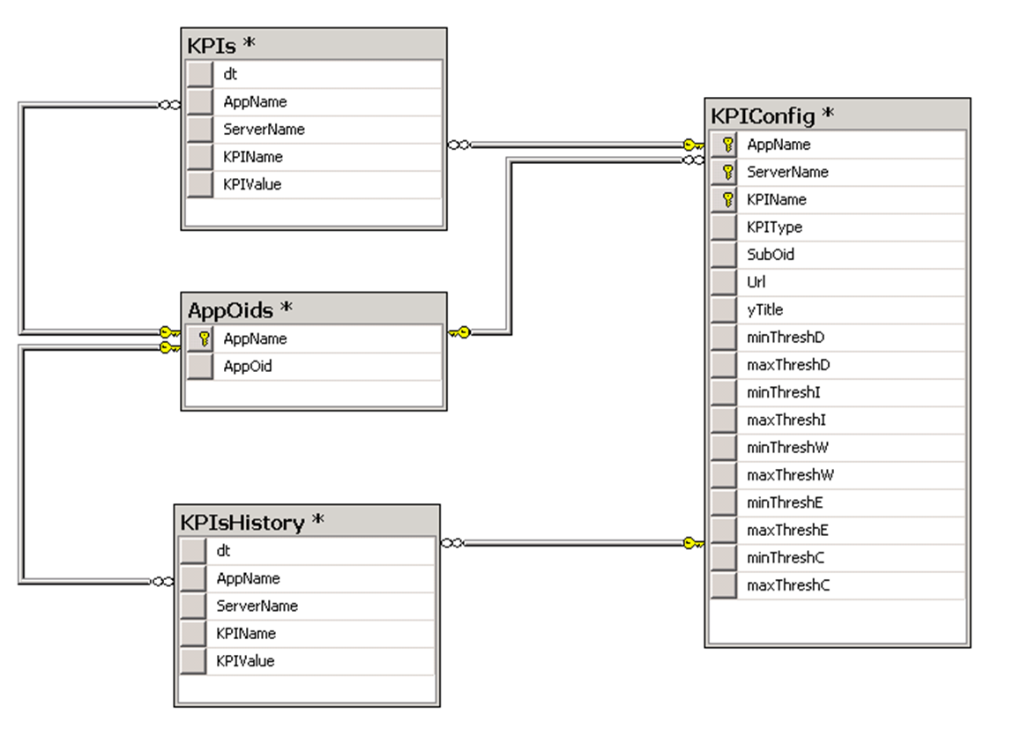
Here’s a description of each table

AppOids
- Associates an AppName with an AppOid.
- It ensures that they are unique within this table

KPIConfig
- This stores the definition of each individual KPI.
- The key is [AppName, ServerName, KPIName]. In other words, a specific instance of a KPI relates to a given app, on a given server.
- The AppName maps to the AppOids table
- The SubOid column must be unique compared to all other KPIs with the same AppName on the same server.
- ServerName relates to the DNA server this KPI belongs to
- The other columns are explained in the Forge documentation (https://confluence.dev.bbc.co.uk/display/forgeops/Automated+application+monitoring+based+on++BBC+ApplicationHostDevice+zenpack)
- The “Thresh” columns are null by default. If they are null, they are not given to Zenoss. This gives us flexibility in defining sensible thresholds appropriate for the KPI

KPIs
- Stores the latest KPIs sampled by the system
- dt is the date and time the KPI was sampled. It’s a SmallDateTime, so it’s accurate to the minute.

KPIsHistory
- As the latest KPIs are requested from the database, all but the current KPIs are moved to this table
- Used purely as a record of the KPIs that the system has sampled, so we know the system is functioning as expected.
- Could be used for analysis at a later date

Stored Procedures
There are a few stored procedures in the db to help with the management and extraction of KPIs.

AddAppOid @AppName varchar(50), @AppOid varchar(100)
- Adds an AppOid to the system, with the associated AppName

E.g.:

exec AddAppOid 'DNA-RipleyServer','1.3.6.1.4.1.2333.3.2.144'

AddKPIConfig @AppName varchar(50), @ServerName varchar(50),
@KPIName varchar(50), @KPIType varchar(50),
@Url nvarchar(1000), @yTitle nvarchar(50)
- Defines a specific KPI for an application on a specific server
- The other params correspond to the Zenoss documentation
- Notice that you do not supply the suboid. The procedure will automatically assign the next available suboid for the specified AppName

E.g.:
exec AddKPIConfig 'DNA-RipleyServer', 'narthur1', 'AverageResponseTime','GAUGE', '<run book URL>','ms'

ChangeKPIThresholds @AppName varchar(50), @ServerName varchar(50),
@KPIName varchar(50), @class varchar(20),
@min int, @max int

- Once you have added a KPI using AddKPIConfig, you can change the values for a specific “class” of threshold
- The tuple [@AppName, @ServerName,@KPIName] uniquely identifies the KPI.
- Set @ServerName to null if you want to change the threshold values for all servers in one go for a specific type of KPI.
- @class can be one of the following (corresponding to the threshold options in the Zenoss documentation):
  - debug
  - info
  - warning
  - error
  - critical
- @min specifies the minimum value for this threshold. Set to null to disable the threshold
- @max specifies the maximum value for this threshold. Set to null to disable the threshold

E.g.:
-- To disable the debug thresholds:
exec ChangeKPIThresholds 'DNA-RipleyServer', 'narthur1', 'AverageResponseTime', 'debug', null, null

-- To set a max warning threshold but no minimum threshold:
exec ChangeKPIThresholds 'DNA-RipleyServer', 'narthur1', 'AverageResponseTime', 'warning', null, 50

-- To set max critical thresholds:
exec ChangeKPIThresholds 'DNA-RipleyServer', 'narthur1', 'AverageResponseTime', 'critical’, null, 500

-- To set min and max warning threshold across all servers:
exec ChangeKPIThresholds 'DNA-RipleyServer', null, 'AverageResponseTime', 'warning’, 20, 200

GetLatestKPIs
- Returns the last instance of each registered KPI (it also moves all but the latest KPIs to the KPIsHistory table)
- It returns the following columns (most of which are self explanatory):
  - Dt: Date and time, to the nearest minute
  - AppOid: The full App OID registered for this app
  - Oid: The full OID for this KPI (i.e. the App OID + the SubOID)
  - AppName
  - ServerName
  - KPIName
  - KPIValue
  - KPIType
  - Url: The URL to the run book entry if an alert goes off
  - yTitle
  - minThreshD: null means undefined
  - maxThreshD: null means undefined
  - minThreshI: null means undefined
  - maxThreshI: null means undefined
  - minThreshW: null means undefined
  - maxThreshW: null means undefined
  - minThreshE: null means undefined
  - maxThreshE: null means undefined
  - minThreshC: null means undefined
  - maxThreshC: null means undefined

BBC.DNA.Monitoring Assembly

The project BBC.DNA.Monitoring builds the assembly that provides the core business logic for collecting and processing DNA KPIs.

The assembly consists of the following classes:

DNAMonitoring
This is the core class that exposes methods that collect KPIs. The methods usually take a server name as a parameter, and return a list of KPIs.

E.g.:
public KPIList GetRipleyServerStatsKPIs(string serverName)

KPI
Encapsulates a specific KPI. Only the name, value and date are modelled here.

KPIList
Contains a list of KPIs extracted from a specific app on a specific server

ZenossKPI
Models the specific Zenoss KPI, with all it’s attributes.
As threshold values are optional, each ZenossKPI contains a list of zero or more ZenossKPIThreshold objects

ZenossKPIThreshold
Contains the name and the value of a specific threshold value. These can be attached to ZenossKPI objects

ZenossKPIList
A list of ZenossKPI objects.
Also provides the “ExportToAppOidFiles()” method needed to write the list of Zenoss KPIs to the correct files.

SSIS DNAMonitoringPackage
SSIS stands for SQL Server Integration Services. It’s a rich development environment designed to build robust Extract, Transform, and Load (ETL) solutions. We used SQL Server 2008 for this particular implementation.

An SSIS package called DNAMonitoringPackage.dtsx was created to control the process of collecting the KPIs and generating the KPI files

Here’s the top level process:
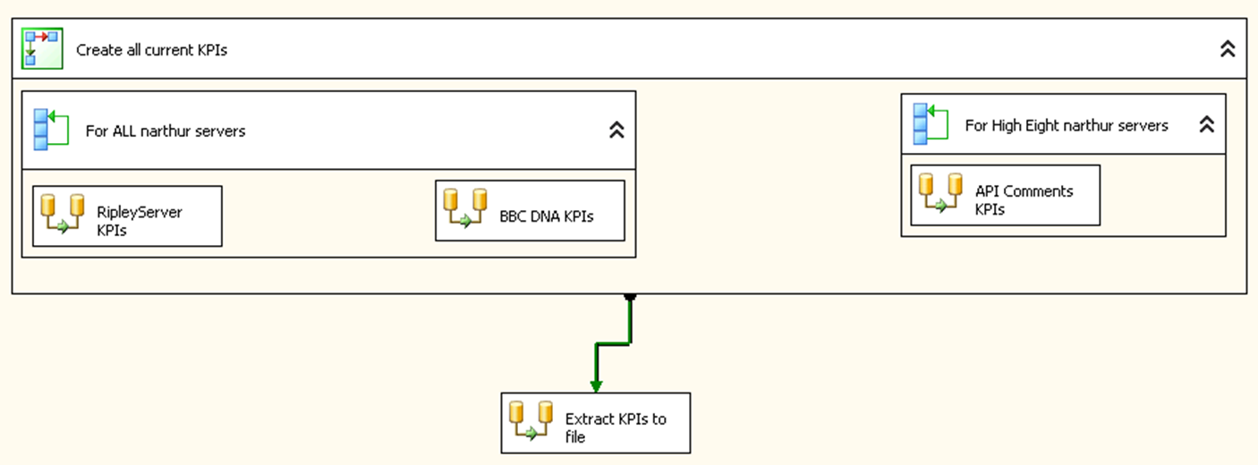

There are two main phases
1) collect all the KPIs into the database
2) extract the KPIs into Zenoss KPI files.

The “Create all current KPIs” section encapsulates all the parts of the process that generate KPIs and stores them in the KPIs table in the DNAMonitoring database.

For DNA, the KPIs are gathered from the servers one at a time. Some sources of KPIs come from all the servers, and some come from a selection of servers. The “For ALL narthur servers” container lists all DNA web servers and calls each task per server. The “For High Eight narthur servers” lists servers narthur8 to narthur15 inclusive, calling it’s tasks per server.

So, for each server, a task is called to collect the KPIs for a particular application. Below is the content of the “Ripey Server KPIs” task

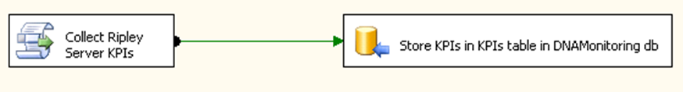

The task “Collect Ripley Server KPIs” collects the KPIs from the server and generates a KPI list. It uses the BBC.DNA.Monitoring assembly to do most of the work. This list is then converted to a data flow, sending the data to “Store KPIs in KPI table in DNAMonitoring db”, which does what it says on the tin

The tasks “BBC DNA KPIs” and “API Comments KPIs” are very similar to the above.

Once all the KPIs have been collected and stored in the KPI table, the task “Extract KPIs to file” is fired. Here’s what’s inside.
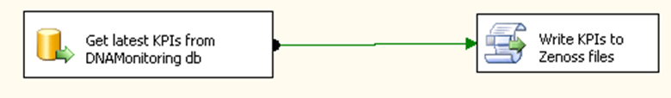

The “Get latest KPIs from DNAMonitoring db” calls the database through stored proc “GetLatestKPIs” to generate a data flow of KPI rows. These rows are passed to “Write KPIs to Zenoss files”, which stores these KPIs, then writes them out to Zenoss KPI files (overwriting existing files if necessary). There’s one file per application, and it uses the AppOid values defined in the database as the file names.

Most of the functionality of “Write KPIs to Zenoss files” is provided in BBC.DNA.Monitoring assembly. In addition, this script calculates the TTL value for the KPIs. The function “CalcTtl()” takes the date the KPI was created and adds 10 minutes to it to generate the TTL value. I’ve put this bit of functionality in the SSIS script so that it’s easy to change once it’s been deployed, if the need arises.

SSIS Package Variables

SSIS allows the creation of variables that tasks can use. You can also create them at different scopes. The system currently uses the following variables:

logFolder (scope: “Package”).This is the folder where Zenoss KPI files are written to. It’s currently set to “C:\usr\local\var\snmp\data”.

serverName (scope “For” loop containers). The “For” loops set this variable for each iteration, and the tasks inside the “For” loops read this var to determine which server to collect KPIs from.

Building and Developing the DNAMonitoringPackage

The package was build and developed in SQL Server Business Intelligence Development Studio 2008 (BIDS), which is a special version of Visual Studio 2008 that contains the project templates used for developing BI solutions.

I created and developed all this on OPS-DNA2, as that has SQL Server 2008, and that’s where the SNMP server is sitting right now. The project can be found in TFS.

Deploying BBC.DNA.Monitoring assembly for DNAMonitoringPackage

The BBC.DNA.Monitoring assembly was developed on my dev machine, and deployed onto OPS-DNA2 each time it changed.

Deploying the assembly is a bit clunky, but I haven’t found a slicker way yet, despite some serious googling. Basically, you have to place the BBC.DNA.Monitoring.DLL in three places:

- <windows>\asembly
- <programFiles>\Microsoft SQL Server\100\DTS\Binn
- <windows>\Microsoft.NET\Framework\v2.0.50727

Once the DLL is in these three places, you can reference the assembly in the Script objects in SSIS. Go to a Script component, double-click, then click on Edit Script… This fires up another VS instance for script editing. Add a reference to BBC.DNA.Monitoring , then start using it.

To update the version, copy the new BBC.DNA.Monitoring DLL to the three places again. Copying the DLL into the “assembly” folder effectively GACs it. Make sure that there is only one BBC.DNA.Monitoring dll in that folder. If there are older ones, right-click and uninstall them.

Unfortunatelty, all the scripts that used the older version will now be broken. The only way I found to update all the scripts so they use the new version of the DLL was to go to each Script component in BIDS, double-click and Edit Script, then close the editor. This forces the script to be recompiled, automatically picking up the latest version of BBC.DNA.Monitoring in the GAC. I can see this being a real pain if/when we add significant numbers of Script components. It’s just about manageable at the moment.

DNA Monitoring job in SQL Server Agent

The process is run at regular intervals via a SQL Server Agent job. It’s a doddle. You simply create a step and set its type as “SQL Server Integration Services Package”, and in the “General” tab set souce as “File system”, and point it to the DNAMonitoringPackage.dtsx built by BIDS.

Make sure the account SQL Server Agent is running under has permissions to write files to the folder configured in the SSIS package under variable “logFolder” – i.e. the folder the Zenoss files are created in.

